PES UNIVERSITY

UE19CS352

Cloud Computing

Lab - 04

Consensus Algorithms: Raft

Name : Suhan B Revankar

SRN : PES2UG19CS412

Section : G Section

1. a

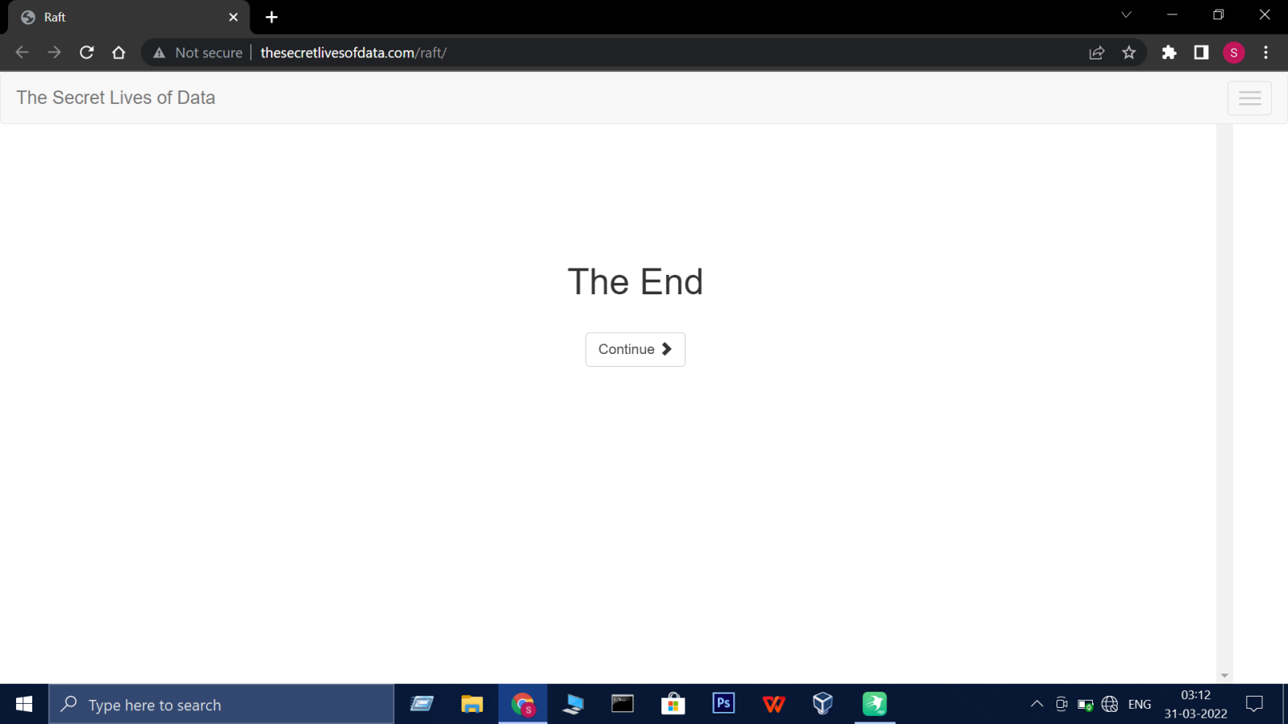

1. b

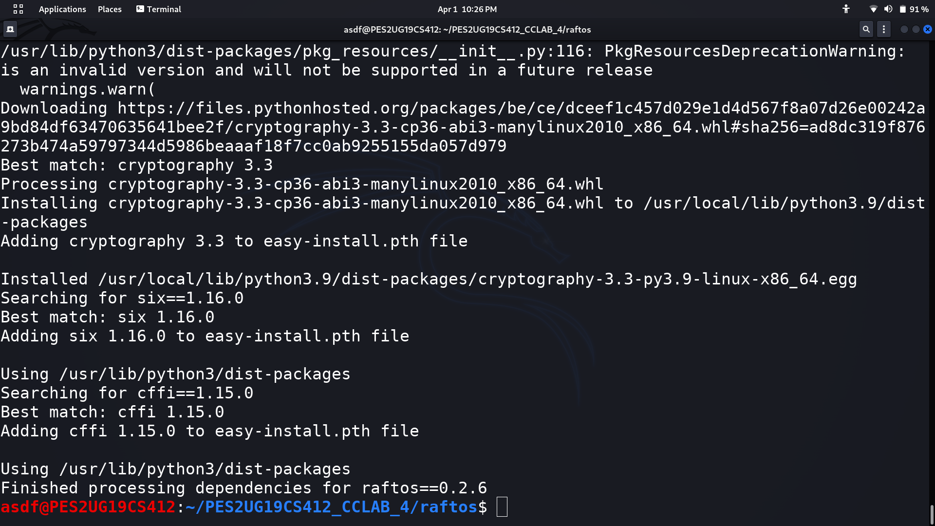

2.a

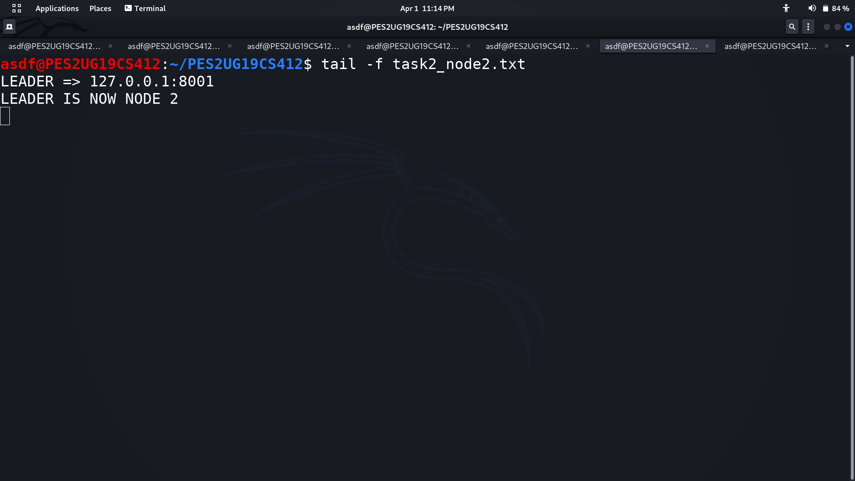

1. b

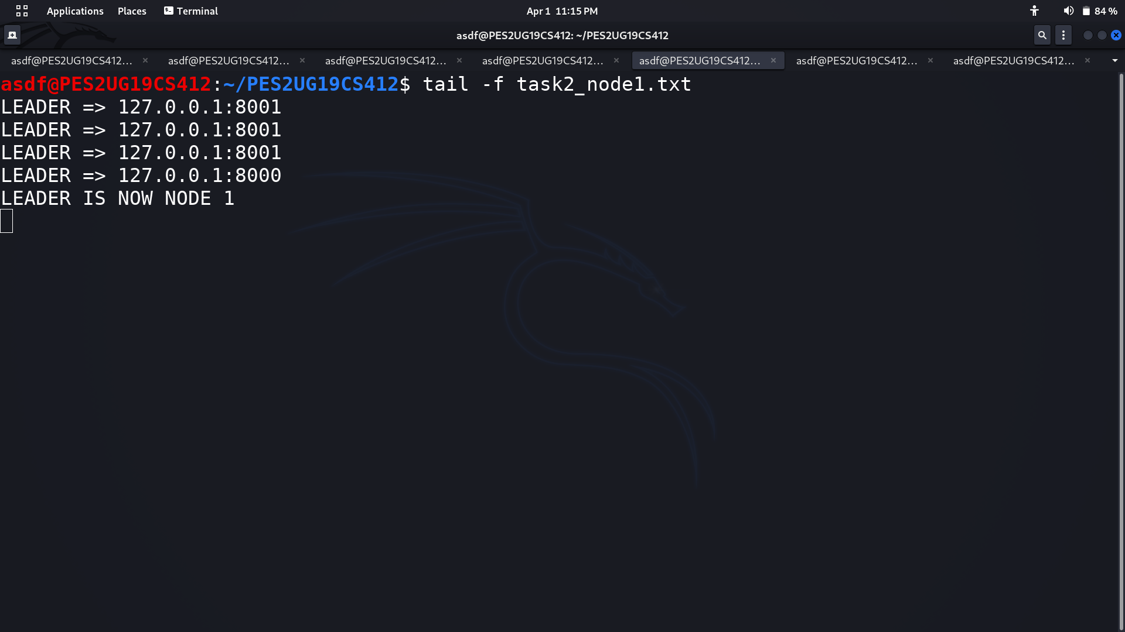

2. c

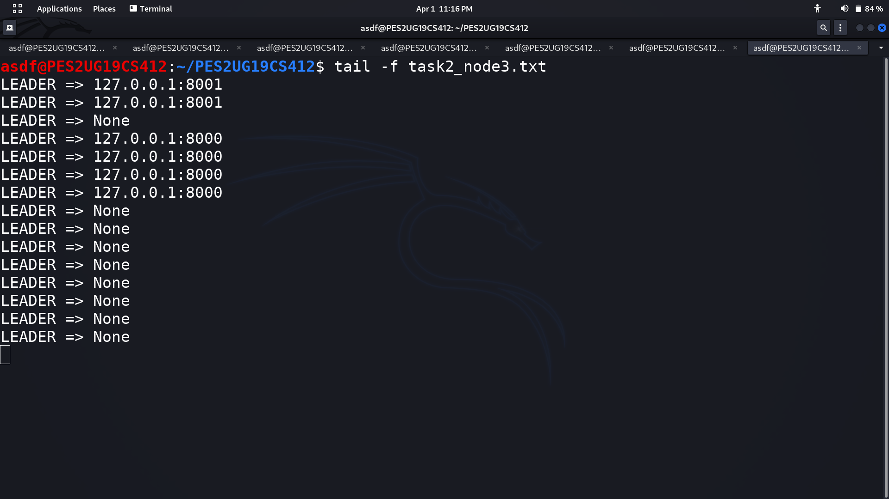

3.a

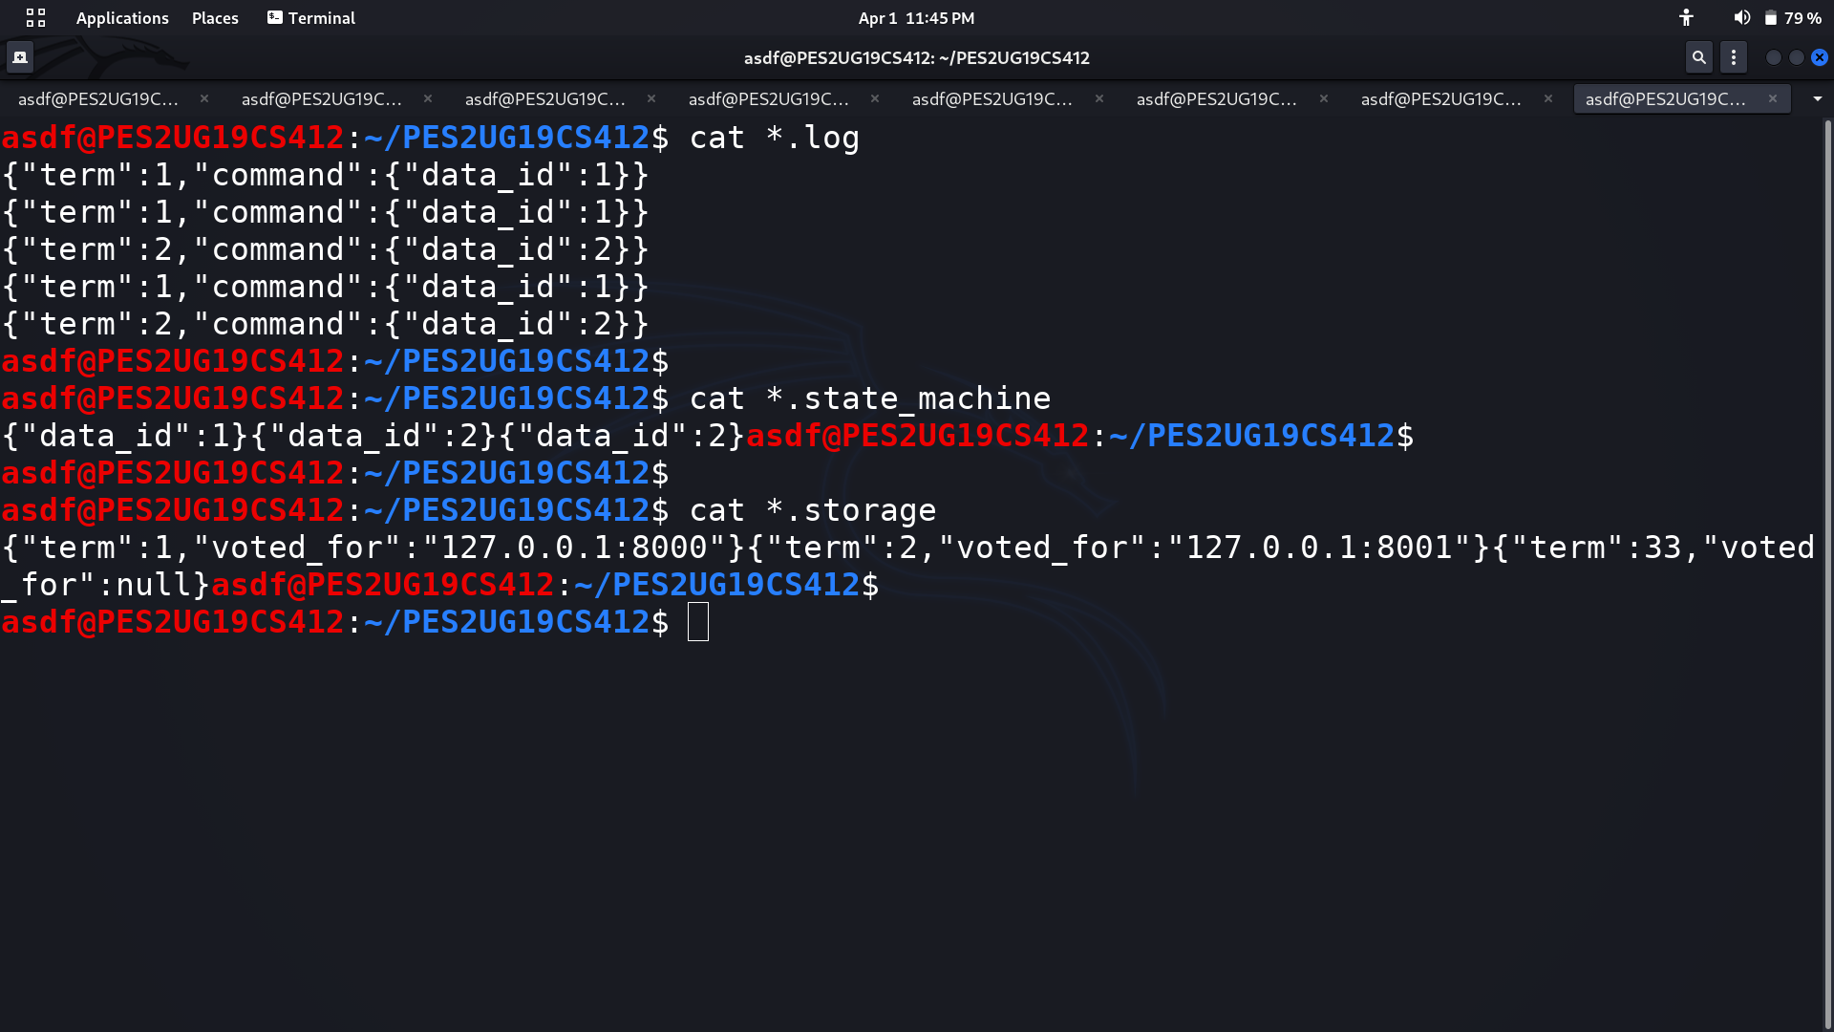

3.b



